**Assignment 1 – GitHub**

CSC/ECE 517 – Fall 2021

[Lecture 1 Introduction video](https://drive.google.com/open?id=17hpCC95cXsN4hD8NDJ_FOwzzKg9zSs3o)

[517_2020_Github_PB_Intro.mp4](https://drive.google.com/open?id=17hpCC95cXsN4hD8NDJ_FOwzzKg9zSs3o)

**Due Date** : August 27, 2021 @ 11:59 PM

*Assignment submission will be verified by the timestamps noted in the*

*repository log*

**Goal** : Gain basic skills required in using Git for a shared codebase,

as well as an initial understanding of [GitHub](https://help.github.com/en/articles/about-project-boards) [Project](https://www.youtube.com/watch?v=C6MGKHkNtxU) [Board](https://codeburst.io/an-introduction-to-github-project-boards-2944e6ffbf3c)

capabilities.

**Piazza** : Feel free to post questions, observations, and tips to Piazza.

*Do not post solutions*.

**Description** : This Assignment is designed as an introductory exercise for

NCSU GitHub Enterprise, GitHub Project Boards, and Git

command sequences. There are several steps to this

assignment and you are encouraged to complete them in

sequence. Each of the tools introduced in this assignment

will be used in this course. By the end, you should feel

comfortable with applying the basics of these in future

homework and projects.

**Note**: For reference, a folder with example screenshots of steps can be

accessed [here](https://drive.google.com/open?id=1N66nu4uOwnaYsIFK41jeN_AEmiHoJ-L1). *\* Disregard the step numbers as they have been adapted for the current semester.*

**Cautious**: Make sure your issues are associated with your project board

Labels and issue names are two separate things, don’t mix them together

Assignment tips can be viewed [here](https://drive.google.com/open?id=1y8_0JbPsUJ92ogKc5hzEls0I5a4C4q23).

**Assignment Instructions** :

1. Sign into [NCSU’s GitHub](https://github.ncsu.edu/)

*If you have never accessed your NCSU GitHub account, a first time login with*

*your NCSU unity id and password is all that is needed to set up the service.*

1. Create a *private* repo: name it *CSC_ECE_517_Assignment_1* and select the option to “*initialize this repository with a README*”.
2. Add the instructor and all TAs as collaborators using their Unity IDs by going to *settings* → *collaborators*
   * Also add yxiao28 (grader)
3. Watch the [GitHub Project Introduction presentation](https://drive.google.com/file/d/10g3hcAgOEg2lHJeIm4I6zQjDJ1N8KKPB/view?usp=sharing).

*This presentation contains specific information about how to complete the remainder of this assignment.*

1. Create a new *private* GitHub Project (via the project tab of your repo): name it *CSC_ECE_517_Assignment_1*, select the [*Basic kanban* template](https://help.github.com/en/articles/about-project-boards#templates-for-project-boards), and link your *Assignment_1* repository.
2. Create Project issues for each of the following, moving tasks appropriately through the kanban board *ToDo → InProgress → Done*, and closing the issue when completed.

*Note: as stated in the above presentation, GitHub Project Board Issues are also*

*known as Tasks. Issues are a generalized card on the Project Board that can*

*represent an item that needs to be completed, fixed, reconsidered, etc.*

* + **Issue 1**
    1. **Label**: Assignment_1 Todo

*This new label should be created as shown in the presentation*

*link in step 4, above.*

* + 1. **Assignees:** yourself

*You are responsible for completing this Issue*

* + 1. **Description**: Complete all the levels in the following “Main” topics of the [Git Tutorial](http://pcottle.github.io/learnGitBranching/) *(1) Introduction Sequence, (2) Ramping Up, (3) Moving Work Around, (4) A Mixed Bag*

*Once you have completed each of the levels required for this task,*

*you should have learned the basics for understanding important git*

*commands and sequences that will be helpful when completing*

*group assignments using a shared code base, such as committing*

*code, merging conflicts, branching, etc.*

* + **Issue 2**
    1. **Label**: Assignment_1 Todo
    2. **Assignees**: yourself
    3. **Description**: Add a screenshot named *completedGitLevels.png* to your CSC_ECE517_Assignment_1 repository that captures your progress

*This image will serve as evidence that you have completed the*

*levels required. It will also give you an opportunity to experience adding files to your NCSU GitHub Repository. Below you will see an example screenshot of what your image should look like.*

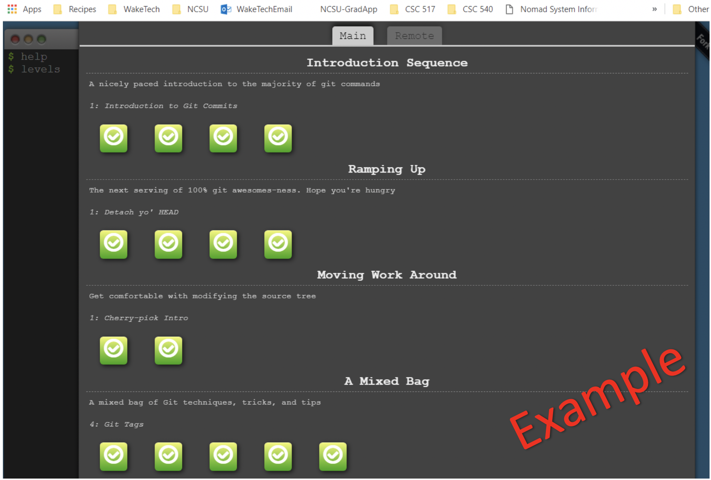

* + **Issue 3**
    1. **Label**: Assignment_1 Todo
    2. **Assignee**: yourself
    3. **Description**: [Embed *completedGitLevels.png*](https://www.youtube.com/watch?v=hHbWF1Bvgf4) within your CSC_ECE_517_Assignment_1 repository README.md

*This will give you an opportunity to work with a markdown file to embed an image into your README.md rather than just inserting a link. You will be required to do this in future assignments to enhance your project wiki pages.*

* + **Issue 4**
    1. **Label:** Assignment_1 Todo
    2. **Assignee**: yourself
    3. **Description**: (1) Add a headshot as your profile picture for your NCSU GitHub account. This picture should include only you and no other people. (2) Update your public name to your first and last name known at NCSU. (3) Update your public email to your ncsu email.

*An individual headshot is beneficial for Dr. Gehringer, TAs, and*

*mentors to become more familiar with whose assignments they are*

*reviewing. “Putting a face to the name”.*

* + **Issue 5**
    1. **Label**: help wanted

*This should be labeled as help wanted, as it is not an Assignment_1 task that you yourself are responsible for completing.*

* + 1. **Assignee**: yxiao28

*Only yxiao28 should be assigned to this issue and no other TAs or*

*mentors, as Kai Xiao will be grading the exercise. There is nothing else to do for this issue.*

1. Putting GitHub commands into practice.
   * Visit the [CSC-ECE-517-Github-practice](https://github.ncsu.edu/yxiao28/CSC-ECE-517-Github-practice) repository
   * Fork the repository

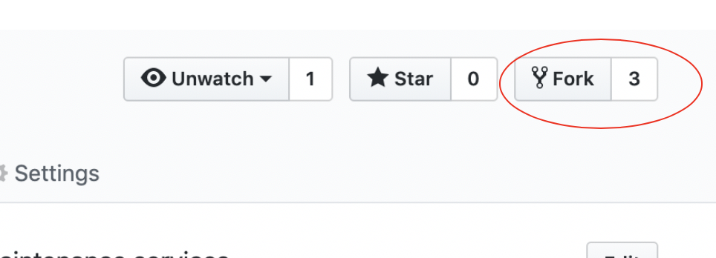

* + Clone your forked repository using the HTTPS clone url and create a branch

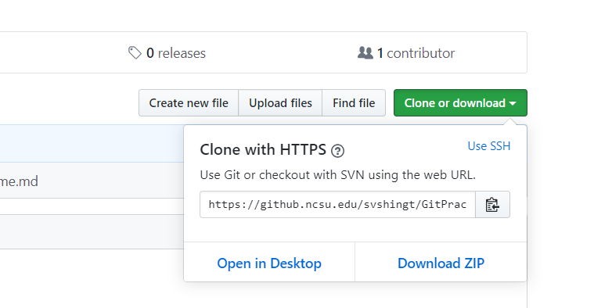

* + 1. git clone [https_url]
    2. git branch // list branches
    3. git checkout -b [unityId] // create new branch from the current HEAD
    4. git branch
    5. git checkout [unityId] // switch to that branch
  + Add a new .txt file with your unity id as the file name (eg. paabhyan.txt)
  + Stage and commit this change
    1. git status // check changes currently staged
    2. git add [filename] // stage changes
    3. git status // check that change was staged
    4. git commit -m “Commit message”
    5. git push origin [unityId] // push branch changes to forked repo
  + Create a pull request. We suggest that you use the GitHub UI to do this. 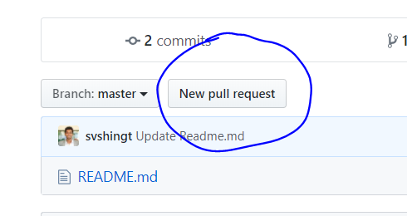
  + This request will notify the repository owner of your requested change. He/She will then review the change and either approve or deny the merge.

1. Self-grade your assignment. To complete this step you should fill out the following assignment grading rubric, awarding and deducting points where appropriate. Once you have completed the rubric, you should include it in your README.md file in the assignment repository. You can do this one of two ways (1) embed a screenshot or (2) create the table using [markdown formatting](https://github.com/adam-p/markdown-here/wiki/Markdown-Cheatsheet)

*To use the rubric simply remove any Partial Deductions for each row from the*

*Possible Points for each row and insert this value into the Points Earned for each*

*row.*

| **Component** | **Possible Assignment Points** | **Partial Deductions**  *\*full deduction taken if component is missing* | **Assignment Points Earned** |
| --- | --- | --- | --- |
| 1. Create a private repo named CSC_ECE_517_Assignment_1 | 4 points |  | 4 |
| 2. Repo contains a README.md file | 2 points |  | 2 |
| 3. Repo includes each of the following as Collaborators | 2 points |  | 2 |
| 4. Created a private project named CSC_ECE_517_Assignment_1 | 4 points |  | 4 |
| 5. Repo contains a .png file named *completedGitLevels* | 2 points |  | 2 |
| 6. *completedGitLevels.png* has been embedded in the repo README | 2 points |  | 2 |
| 7. Completed all 15 levels of the online git tutorial | 15 points |  | 15 |
| 8. Project Board Issue #1 | 8 points |  | 8 |
| 9. Project Board Issue #2 | 8 points |  | 8 |
| 10. Project Board Issue #3 | 8 points |  | 8 |
| 11. Project Board Issue #4 | 11 points |  | 11 |
| 12. Project Board Issue #5 | 4 points |  | 4 |
| 13. Completed Assignment Rubric embedded in README.md or included via markdown formatting. | 2 Points | *None* | 2 |
| 14. Pull request received with new file [unity.txt] requested to be merged into GitPractice_517_F20 | 2 Points | *None* | 2 |

1. Your final grade will be computed based on **3** randomly selected rows from the above Assignment Grading Rubric.

*Example: grading based on scores accumulated from rows 1, 8, and 12.*

Your grade will then be given based on the percentage of assignment points

earned from the total possible assignment points of those rows.

*Possible Example Grading Results: 18 possible assignment points*

| *18/18 = 100 %*  *17/18 = 94%*  *16/18 = 89%*  *15/18 = 83%*  *14/18 = 78%*  *13/18 = 72%* | *12/18 = 67%*  *11/18 = 61%*  *10/18 = 56%*  *9/18 = 50%*  *8/18 = 44%*  *7/18 = 39%* | *6/18 = 33%*  *5/18 = 28%*  *4/18 = 22%*  *3/18 = 17%*  *2/18 = 11%*  *1/18 = 6%*  *0/18 = 0%* |
| --- | --- | --- |

The percentage of assignment points earned will be translated

as a percentage of course points that you earned for this assignment.

*Example : Assignment 1 is worth 10 course points and you earned 94% of*

*the possible assignment points. This translates to earning 9.4 course points.*